- MINIMAX ALGORITHM
AIM
To implement the Minimax algorithm in Python for a Tic-Tac-Toe game, where the computer selects the best possible move against the player.
OBJECTIVE
- To understand the Minimax decision-making algorithm.
- To implement a game between a human and computer.
- To make the computer choose the optimal move.
- To determine the winner or draw.
ALGORITHM
- Start the program.
- Initialize the Tic-Tac-Toe board.
- Define all possible winning combinations.
- Accept the player's move manually.
- Check whether the player has won.
- If not, apply the Minimax algorithm to find the best computer move.
- Place the computer's move on the board.
- Check whether the computer has won.
- Repeat the process until a player wins or the board is full.
- Display the winner or draw.
- Stop.

FLOWCHART:
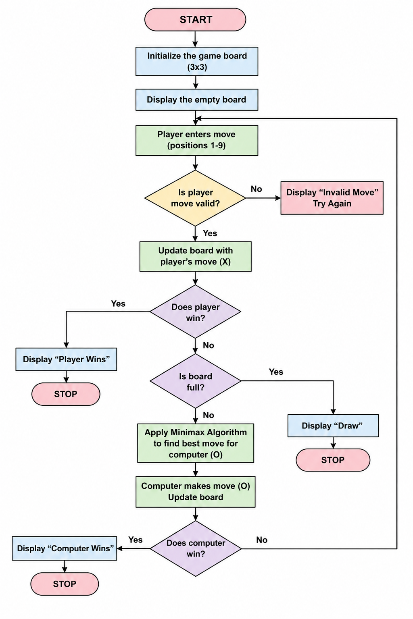
PYTHON CODE:
b=[" "]*9
w=[(0,1,2),(3,4,5),(6,7,8),(0,3,6),(1,4,7),(2,5,8),(0,4,8),(2,4,6)]
def win(p): return any(all(b[i]==p for i in x) for x in w)
def mini(maxi):
if win("O"): return 1
if win("X"): return -1
if " " not in b: return 0
s=[]
for i in range(9):
if b[i]==" ":
b[i]="O" if maxi else "X"
s.append(mini(not maxi)); b[i]=" "
return max(s) if maxi else min(s)
for t in range(9):
print(b[0:3],b[3:6],b[6:9])
if t%2==0:
p=int(input("Enter position (1-9): "))-1
if b[p]!=" ": continue
b[p]="X"
else:
m=max((mini(False),i) for i in range(9) if b[i]==" ")[1]
b[m]="O"
if win("X"): print("You Win!"); break
if win("O"): print("Computer Wins!"); break
else: print("Draw!")
OUTPUT:
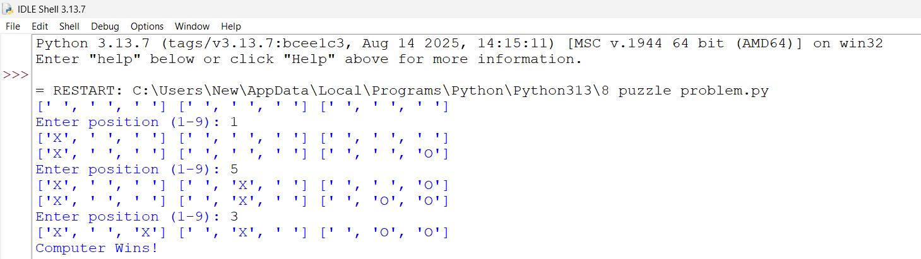
RESULT:
Thus, the Tic-Tac-Toe game was successfully implemented in Python using manual input. The program correctly identifies the winner or declares a draw.

